**Login to mailchimp**

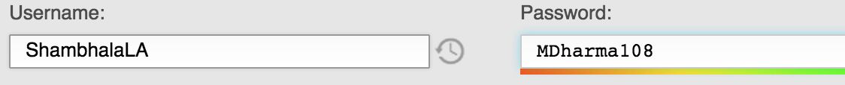

Go to campaigns

replicate a new newsletter or click edit

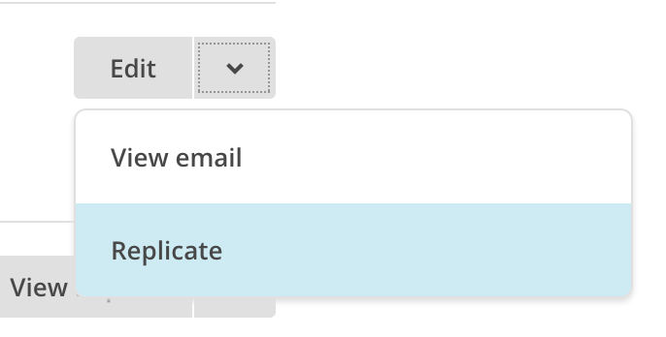

In SETUP tab, edit the subject, google analytics (change date) etc

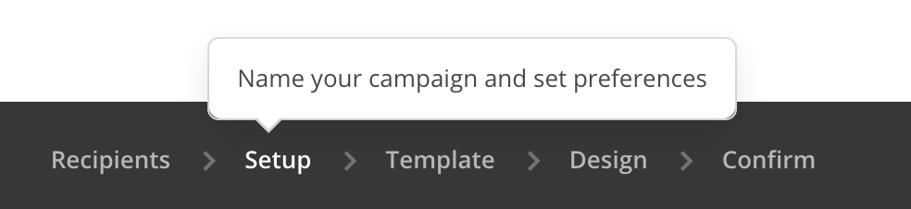

The size for the images that are large should not exceed 600 pixels. I have found that 580px in width is the best size for our featured programs.

**In DESIGN tab**

**Add the upcoming programs**

**Check the monthly calendar. Add the intro programs unless specified from communications lead what to add.**

**Check that the BLOG posts are current**

**IN CONFIRM tab**

**Click on PLAIN-TEXT EMAIL, Regenerate from HTML and SAVE**

**Click on EDIT for SOCIAL CARDS enter a short new description. Update the photo. Click on NEXT to choose a new photo.**

**CLICK SCHEDULE button**

**Let mailchimp decide when best time to send.**

**DESIGN TAB NOTES**

**To replace an image, click on pen icon**

Then REPLACE. Also update the LINK if necessary as well as ALT (= the text that will appear if the images won’t appear in message)

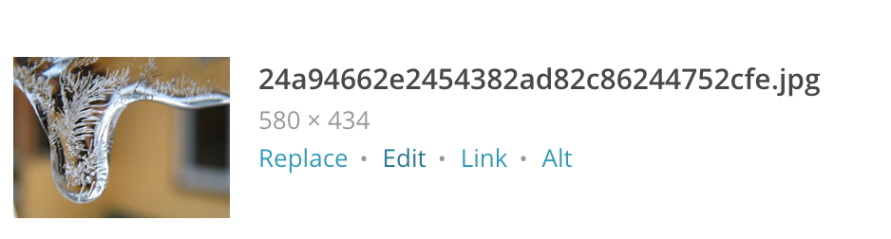

When you copy and paste from the website, it embeds the formatting. To get rid of that you select the text and click “CLEAR STYLES”

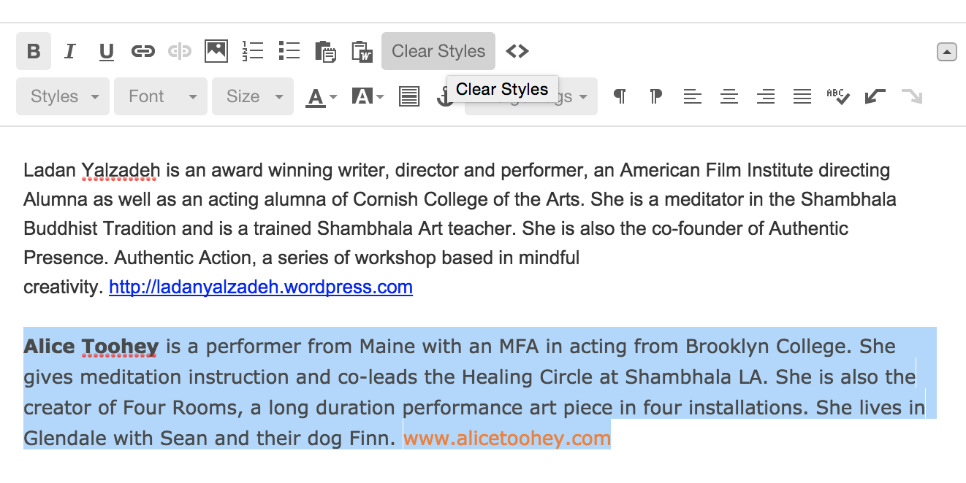

Make sure the photos are linked to the program

you can click and drag the different blocks (=text, buttons, images)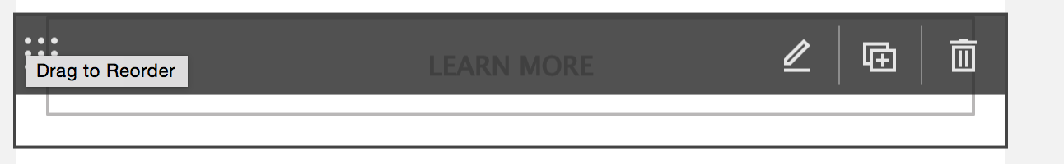

To copy, just click on the plus icon.

When you have added the information below please send me and Jenny a test email

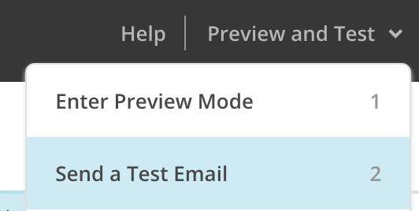

PLEASE NOTE

The template has already set fonts